Week 2:

This week’s topic is about system engineering. Overall, the lecturer introduced some fundamental concept of SE around the topic of it, such as system fundamentals, science, lifecycle. I personally regard this week’s lecture as the introduction of some SE basic concepts. The lecture focuses on two important foundations: system thinking, which will be one topic of week 4, and lifecycle model.

Because I am a BIT student with few engineering experience, I browsed Google and Wikipedia for consolidating related knowledge. The system thinking is a method which not only considers the similarities between different system in various domains, but also help people recognize the system entirely, including the overall structure, patterns and cycles. It has the feedback loop (shown below). I noticed that this concept will be introduced in detail in the following weeks. Hence, I am able to obtain a detailed and accurate thought in week 4.



Then the slides showed the next concept – Lifecycle processes. It introduces some standard processes and two famous and classical development models (scrum and waterfall). This reminds me of what I learned from the course COMP3120. Scrum is a classification and methodology of Agile. When the agile method is applied, the project manager divides developers into groups and allocates the related work to them, which are usually some small chunks of the project. Then during the starting process, they hold meetings, discuss and integrate their schedule and ideas, then iterate the process. Waterfall method was originally designed by software developers and was applied as a traditional develop method for many years. However, it has the terrible weakness. When the requirement is changed, it always implies the failure of project. Due to this reason, waterfall method is gradually replaced by Agile method in many actual developments.

To sum up, in my opinion, to some extends, system engineering is similar with software engineering as large and complicated software is a kind of system. I am not sure whether SE often requires to optimize but as a system, it relies on optimizations. Maybe this is the obvious difference between these two concepts?

Week 3:

Mrs. Steph Mellor, from the Thinkplace Company, was invited to attend this week’s lecture – Design Thinking which is manifested through methods and processes. The design thinking pays more attention to the problems itself rather than making assumptions on the solutions.

Some scholars in Stanford University summarized this method in these 5 steps in order to educate people with a clear mind of ‘human-centred’, which is also mentioned in today’s tutorial. Some steps are obvious and easy to understand. The core is the empathize, which is to collect the requirement of the users. Steph also pointed out that it is also the most difficult in the 5-step method.

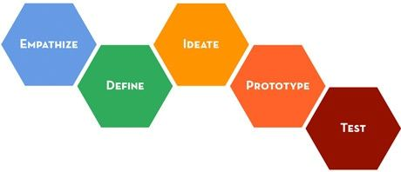

After the lecture and today’s useful tutorial, in my opinion, the most significant principle in design thinking is creativity, which is also the foundation of it. Bringing out an idea is like brainstorming, planned ideas should be regarded justifiable. Never give up any ideas no matter how it looks or listens useless and stupid. When you come up with an idea, write it down and draw a prototype on paper. Then test it as this is an important lesson in which we are able to acquire experiences. Try to iterate to find a solution if it fails. This is a meaningful suggestion for most entrepreneurs. Meanwhile, Steph mentioned a new concept which I never heard before, that is co-design. No one or group of people have the whole picture. Hence, keeping the co-design method in the mind because users always encounter the difficulty in understanding the cultural, societal, or usage scenarios. (En.wikipedia.org, 2017)

Next week’s topic is about system thinking. I often wonder what is the difference between these two concepts. By using Google, personally, the process of developing solutions is the core of design thinking while system thinking focuses on the understanding and the process of testing the object without the solution. I hope to obtain more related knowledge in the next week lecture.

Reference:

1. En.wikipedia.org. (2017). *Participatory design*. [online] Available at: https://en.wikipedia.org/wiki/Participatory_design#Co-design [Accessed 9 Mar. 2017].

Week 4:

This week’s topic is about system thinking. Overall, the lecturer introduced two types of the new concept of feedback loop which indicates the interaction between the stock and the flows. After the learning of the lecture and the discussion with classmates during the tutorial yesterday, in my opinion, the system thinking focuses on the holistic system for people to explore the functions of system, which regards the whole system as an entirety instead of paying close attention to individuals.

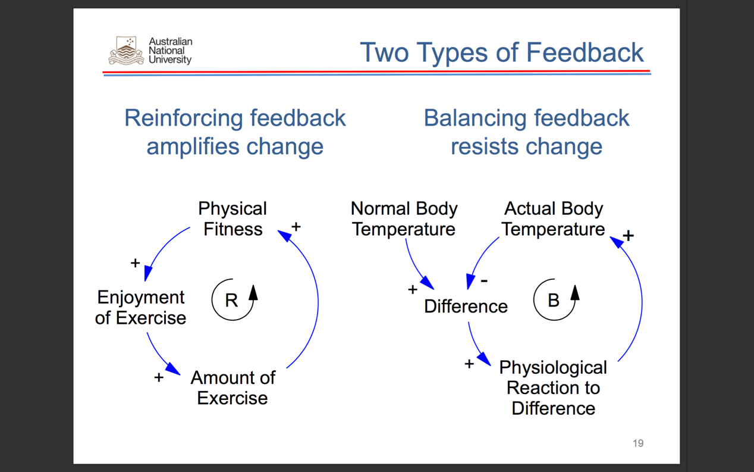

When we were broken up into small groups, some colleagues talked about his design experiences related to the system thinking. Actually, I did not do much designs. Therefore, what impressed me a lot is the system thinking practice. Our group paid attention to the topic of the war on terror. In the R feedback model, the topic is divided into 4 parts.

Problem: Terrorism

Problem symptom: The attack by terrorists

Fix: The country adds more military

Unexpected consequences: Military spending is increased and meanwhile, it raises the burden on the people.

During the practice in the lecture, I have a question of the difference between system thinking and design thinking. After the tutorial, the question was still in my mind. Thus, I browsed in the Google and find the answer. Actually, they do not have a compact relationship but they are able to cooperate to resolve problems. Design thinking focuses on the synthesis and relies on building and creating to figure out the problems, while system thinking is the process of analysis of the component and the entire system (Spacey, 2017). For instance, when consider constructing flood-control levees in system thinking method, we are always required to think the problem, the problem symptom, unexpected results and how to fix it. However, in design thinking way, the designer focuses on how to construct a flood-control levee.

In conclusion, system thinking contributes to keep a clear mind of ‘big picture’ which will be learned in the remaining weeks. Meanwhile, system thinking help me generally realize how SE really works by applying the system thinking method and understand to deal with complicated problems in the real world with the mind of system thinking.

Reference:

1. Spacey, J. (2017). *Design Thinking vs Systems Thinking*. [online] Simplicable. Available at: http://simplicable.com/new/design-thinking-vs-systems-thinking [Accessed 18 Mar. 2017].

Week 5:

Dr. Lorrae van Kerkhoff and Dr. Tom Worthington hosted this week’s topic on Environmental concerns. To some degree, in my opinion, it is not necessarily a related topic for system engineering, even I thought whether it was relevant to the compiled environment when I first got this topic. However, after we done the tutorial facilitation, actually the computers do produce huge carbon dioxide and consume unbelievable amount of energy. Thus, we are supposed to focus on not only the system and design thinking, but also some environmental concerns because basically it is a kind of hardware issue.

We did the tutorial facilitation this week so I think we catch more related knowledge and background than others. The engineering, in developed countries, has been adjusted and optimized to deal with the environmental issues for 200 years! Now people always praise the grandness and gorgeousness of London, but who could imagine that it is like a living hell in the late 1850s due to the terrible atmosphere and the incredible death rate of it. The government made decisions to manage the environment and optimize economic structure for generations and obtained today’s positive feedbacks. Nevertheless, in some developing countries, the governments haven’t realized the issues and pursue the economic development exceedingly. Thus, as a software engineer, it is our responsibilities to attract public’s attentions on the environmental issues.

For this purpose, in this week’s tutorial, Haotian and I tried to introduce some actual cases in developing countries and shared some optimized solutions to improve the environment and decrease carbon dioxide emissions. During the facilitation delivery, we were a little bit nervous and encountered a display tech issue at the beginning. Finally, we realized our goals and arranged some discussions for our colleagues to share their opinions on the whiteboard. This experience is like a treasure in my lifetime.

To sum up, not only engineers, but also others are supposed to understand the authentic circumstances, especially in developing countries. The usage of fossil fuel in industries and daily life is still incredible. Although technology plays the important role in decreasing CO2 emissions and providing efficient solutions to public, the promotion of environment quality is not able to be without everyone’s effort. In addition, big boss in developing countries, China and India, should take the charge to lead others and learn the experience from developed countries. Specifically, stimulation or regulation of economic structure is requisite so that the governments have to adequately understand the global economics and development. Thus, it can be seen that the environmental issues will not be a ‘issue’ in the future.